A low cost implementation of MQTT using ESP8266

Ravi Kishore Kodali and Kopulwar Shishir Mahesh Department of Electronics and Communication Engineering National Institute of Technology, Warangal

WARANGAL 506004 INDIA

Email: [ravikk](mailto:ravikkodali@gmail.com)[odali@gmail.com](mailto:odali@gmail.com)

***Abstract*—Technology is great growling engine of the change and Internet of Things (IoT) is the backbone of such revolu- tionary engines. Basically, in the real world the things having sensor capability, sufﬁcient power supply and connectivity to internet makes ﬁeld like Internet of Things (IoT) possible. For such rapid growing technology, it is the necessity to have very light, inexpensive and minimum bandwidth protocol like Message Queuing Telemetry Transport (MQTT) Protocol. Because of such non-established protocol it is easy for the clients to publish or/and subscribe the desire topic through the host acting as server of the network also known to be the broker. In this paper, it is shown that communication between the low power ESP8266 WiFi as client with the clients on smartphones and laptop using an MQTT protocol becomes easier and more reliable. The WiFi enabled ESP8266 board interfaces with DHT11 sensor and LDR sensor to monitor the ambient condition and according to the light intensity level the brightness level of 8*8 Neopixel matrix is controlled. The adafruit.io is the MQTT server i.e, broker which also provides the facility of monitoring system through the dashboard. The clients on smartphone and laptop subscribes to the topics of temperature, humidity and light intensity level gets the respective update. The main objective of the paper is to implement the idea for the smart home appliance, street light system for the smart cities, ﬁre alert systems, whether monitoring system and so.**

cities smart, it is important to apply smart solutions to the infrastructure and services to make it better plan by reducing the manpower, more throughput with less investments, lower cost for redevelopment and retroﬁtting[9]. The street lights for such smart cities is one of the main concern and requires system which can able to control street lights automatically so as to match the brightness level of street lights with an environment condition providing the information of ambient light intensity level along with the temperature, humidity of surroundings.

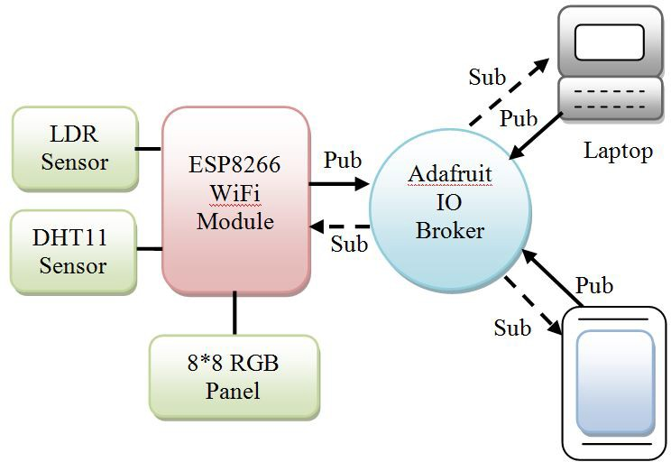For the ﬁre alert system, the end user can keep an eye on the ambient conditions by monitoring and analyzing the conditions and can take subsequent action if needed. Also, the idea can be implemented for whether monitoring systems.

1. INTRODUCTION

It is the human race to enhance the technology everyday everywhere. One of the simplest clue is to make the environ- ment around us wireless rather than the bulkier wired one. In our home, the power outlet uses analog switches and bulkier circuitry within it, in addition there are chances of getting it damaged with the time and need a replacement plus the outlet is kept in speciﬁc height in order to avoid shock to children. What if all these problem can be resolved with the simple design and implementation using a low power, low cost technology wherein the home lights are being controlled automatically with respect to ambient light conditions in addition with the temperature and humidity monitoring. Also there can be provision for user to make a decision to let the system turned ON and OFF remotely. With each user having its own username and key the system can be made secured and the user will able to control the system anywhere in the world having the internet connectivity.

The Smart cities is one of the major application of the Internet of Things (IoT) technology. In order to make the

Fig. 1. System Conﬁguration

The MQTT is the Message Queuing Telemetry Transport protocol which makes the communication independent of request response approach by simply providing subscribe- publish architecture asynchronously. Basically, it is light weight IoT protocol working on default TCP/IP with port 1883[4]. It is an open protocol standardize by OASIS Tech- nical Committee which determines how each message is delivered from clients to clients through the broker, it is very easy to implement and provides Quality of Services(QoS) to the communication network with the minimum network

bandwidth, also ensures the reliability and some degree of assurance of delivery[8].

1. LITERATURE SURVEY

In the IoT, the MQTT is a popular topic-based protocol [15]. This paper extend the topic approach by developing a new model in an IoT concept which is Web of Topics(WoX). This novel design model reduces the gap between design and solution domain in the IoT. The MQTT publish/subscribe messaging protocol helps to provide capabilities to transmit or receive sensor data [4]. This paper has created a secured home automation system using MQTT protocol and also ACL (access control list) for encryption of sensor data. The MQTT messaging protocol provides the robust messaging features that is needed for communication between remote system and devices with consumption of very small network bandwidth [6]. So for the design and implementation of this lightweight protocol an authorized mechanism is introduced for IoT services [2]. This design is based on OAuth 1.0a, which is an open authorization standard for web based application.

One of the major concern in the ﬁeld of IoT is the security of devices and communication among them [3]. To overcome this issue, this paper proposed a new version of SMQTT and MQTT-SN protocol. Its key features gives the better security than previously existing MQTT.

There is major challenge for high demand of electrical power consumption due to global warming and lack of natural resources [16]. In this approach, one applicable method is designed for the optimization of electrical power consumption by using light dependent Registor (LDR). It automatically optimize the light intensity according to the sensor readings, thus it saves a lot of power in daytime.

The MQTT protocol is ideal for use in M2M communication [17]. It enables connectivity that extends beyond smart devices to some of the smallest remote devices and sensors. This key features makes MQTT a critical component in self- managing of M2M networks[5]. This paper discusses the development and implementation of MQTT protocol for such kind of application along with its merits and demerits.

1. CIRCUIT AND WORKING

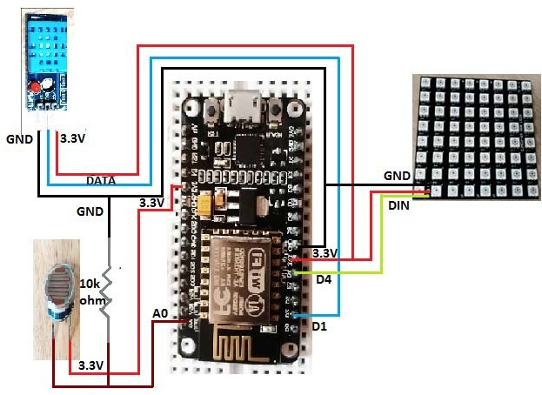

Fig. 2. Schematic diagram

As in the circuit diagram, ESP8266 Nodemcu is USB powered and for the ambient conditions to monitor the two sensors namely DHT11 Sensor for temperature and humidity monitoring and LDR Sensor (Light Dependent Resistor) for monitoring light intensity level are interfaced with it. And depending on ambient light condition, the brightness level of Neopixel 8*8 RGB matrix will change that is it is programmed in such a way that for the more intense light condition the brightness level Neopixel 8*8 RGB matrix will be lesser and for lesser intensive light its brightness will be higher. The one pin of LDR Sensor is connected to the 3.3V of ESP8266 board and the other pin is connected to one end of 10K resistor and the same end is connected to the ADC pin A0 of the ESP8266 board while the other end of 10K resistor is grounded. The VCC and GND of DHT11 Sensor is connected to the 3.3V and GND of ESP8266 board while GPIO13 i.e, D1 pin of ESP8266 board is programmed for the DATA input of the DHT11 Sensor. For interfacing Neopixel 8*8 RGB matrix, the VCC and GND connected to 3.3V and GND of ESP8266 and GPIO2 i.e, D4 pin of ESP8266 board is programmed for the DIN input of panel.

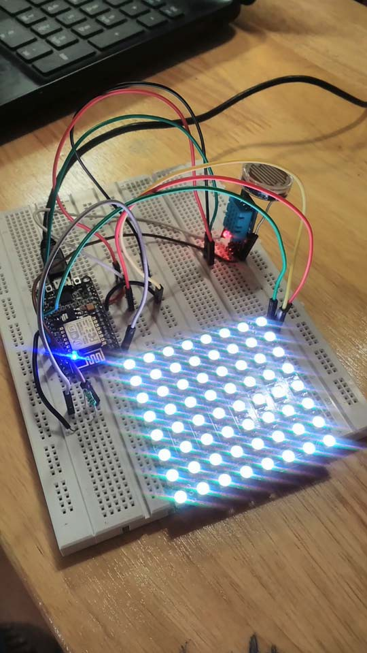

Fig. 3. Circuit Connection of System

The ADC pin of ESP8266 has 10 bit resolution which will vary analog reading from 0 to 1023[10]. The ADC pin only converts voltage between 0 to 1V. On the other hand, each pixel of the three primary color of 8*8 RGB Neopixel matrix has 8 bit resolution for an individual Red, Green and Blue color and thus comprising the total 256 brightness level for the three primary colors Red, Green and Blue color ranging from 0 to 255[12]. When the brightness of each primary colors are equal it will result in white color and the brightness of that white color will vary from 0 basically no color to the 255 the brightest level.

Now, the light intensity levels of LDR Sensor are divided into sub-levels and are organized with the 256 brightness level of each pixel of Neopixel 8*8 RGB matrix as shown in the following table:

TABLE I

DIVISION OF LIGHT INTENSITY LEVEL VS BRIGHTNESS LEVEL

|  |  |
| --- | --- |
| Light Intensity Level of LDR Sensor | Brightness level of each pixel of 8*8 Neopixel panel |
| 0 - 199 | 255 |
| 200 399 | 150 |
| 400 599 | 100 |
| 600 899 | 50 |
| 900 1024 | 0 |

In the proposed system, the Adafruit IO is MQTT server also known as broker and ESP8266, smartphone, laptop are the clients. The information of light intensity level, temperature and humidity of surrounding environment can be published to the broker with its user deﬁned light, temp and humid topic name respectively. Once these data has been published by client ESP8266 then the clients on the other side like smartphone, laptop who have subscribes to that particular topic gets that respective information.

1. HARDWARE ASPECT
2. *ESP8266 ESP-12E WiFi Module*

The module is best suited for Internet of Things(IoT) at its low cost, low power consumption capability as it requires 3.3V power , built in WiFi module, integrated TCP/IP protocol stack, easy to ﬂash and erase ﬁrmware and is usb powered[10]. As the IoT application module it can deploy in home automa- tions, home appliances, industrial wireless network, sensor networks ﬁelds.

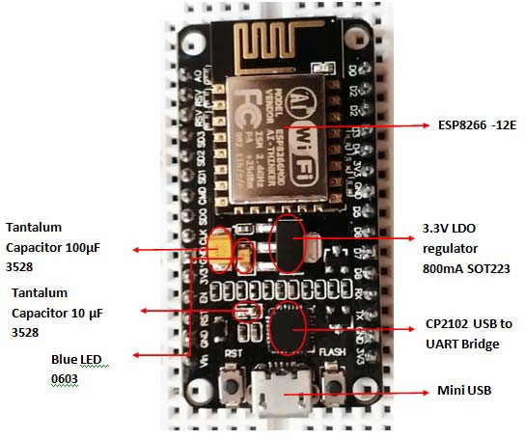

Fig. 4. ESP8266 ESP-12E Development Board

TABLE II

ESP8266 ESP-12E WIFI MODULE SPECIFICATION

|  |  |
| --- | --- |
| Parameters | Speciﬁcation |
| Microcontroller | ESP8266 |
| Memory | 32 bit |
| Processor | TenSilica L 106 |
| Processor Clock | 80MHz-160MHz |
| RAM | ¡ 36Kb |
| Storage | 16 Mb |
| Built-in WiFi | 2.4GHz supports 802.11 b/g/n |
| ADC Pin | 1(10bit Resolution) |
| GPIO pins | 10 |
| Operating Voltage | 3.0V 3.6V |
| Operating Current | 80mA(Average) |
| Operating Temperature Range | -40oC - 125 oC |

1. *DHT11 Sensor*

The Digital Temperature and Humidity sensor DHT11 comes with the ultra small size of 12 x 15.5 x 5.5 mm, low prices, highly reliable, optimized for long term stability having single wire digital interface[11]. It is used for whether monitoring, home automation, ﬁre alert system purposes.

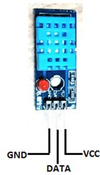

Fig. 5. DHT11 Sensor

TABLE III

DHT11 SENSOR SPECIFICATION

|  |  |
| --- | --- |
| Parameters | Speciﬁcation |
| Input Output Voltage | 3V 5V |
| Humidity Range | 20-80 perc |
| Temperature Range | 0-50 deg C |
| Sampling Rate | 1Hz |
| Response time | 50ms |

1. *LDR Sensor*

The Light Dependent Resistor is made of semiconductor material where luminance variation occurs due to the conduc- tance changes. It possesses good reliability, high sensitivity, small volume, fast response and the good spectrum characteris- tics[14]. It is having wide range of applications in light control, camera automation, street lights, ﬁre alert system, indoor ray control[14].

1. 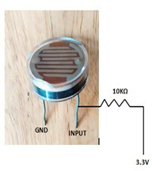SOFTWARE ASPECT

*A. Arduino IDE*

Fig. 6. LDR Sensor TABLE IV

LDR SENSOR SPECIFICATION

|  |  |
| --- | --- |
| Parameters | Speciﬁcation |
| Model | PGM2000 |
| Physical Size | 20mm |
| Vmax(DC) | 500 |
| Ambient Temperature | -30-+70 deg C |
| Spectral Peak | 560nm |
| Photo Resistance | 2-5K Ohm |
| Dark Resistance | 1M Ohm |
| Response Time | 3040 ms |

1. *Neopixel 8*8 RGB LED Matrix*

It is full color module wherein each RGB LED of primary colors can achieve 256 brightness level, the colors of light are highly consistent and cost effective[12]. The WS1812B is an intelligent control LED light source that control circuit[12]. The LED is having low driving voltage, environmental pro- tection, energy saving, high brightness and long life.

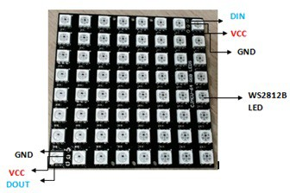

Fig. 7. Neopixel 8*8 RGB LED Matrix

TABLE V

NEOPIXEL 8*8 RGB LED MATRIX SPECIFICATION

|  |  |
| --- | --- |
| Parameters | Speciﬁcation |
| Supply voltage | 5V |
| Number of pixels | 64 |
| Brightness Level | 256 |
| Scan Frequency | 400Hz |
| Sending data Speed | 800Kbps |
| Total colors | 16777216 |

In Arduino IDE, the one has to put Server name i.e, io.adafruit.com, Server port number 1883 which is TCP/IP port reserved to use MQTT protocol, Username of Adafruit account, the unique AIO key which can be regenerate, setup feed and provide feed name which is the topic name that can subscribe or/and publish through the server, SSID and password of the WiFi access point having internet connectivity. Once everything is conﬁgured properly, the code is compiled and uploaded to the ESP8266 WiFi module.

*B. MQTT Server*

The MQTT server provides Quality of Services to deﬁne the priority to messages that are published and subscribed[1]. The Adafruit IO supports MQTT protocol for device commu- nication. For an authentication purpose the one has to create an account on Adafruit.io with basic details and they will be ready to use that broker. Basically, it will introduce with an account username, key and feed. The name of the account is designated as username, the key is use to authenticate any device that is long and is unique identiﬁer which is designated as AIO key, the feed is like sequential ﬁle having set of data that can be read or write[7].

*C. MQTT Clients*

1. *MQTT Spy:* It is an open source utility for publishing and monitoring activity on MQTT topics which supports multiple concurrent connections, supports MQTT connection properties like QoS, User Authentication, SSL/TLS[13]. Au- tomated testing is written in JavaScript. The functionality of charts and statistics are also available[13].
2. *MQTT client:* This app is installed on Android smart- phone which adds/removes topic easily, conﬁguration is easy, gives the notiﬁcation for a new message, ability to hide notiﬁcation for some topics and support SSL connection.
3. EXPERIMENTAL RESULTS

At the inception, ESP8266 commence connecting to the WiFi access point having internet connectivity, after the suc- cessful connection it starts for the MQTT connection and once MQTT connection is made between broker and clients, it starts giving the results as shown in the ﬁgure below:

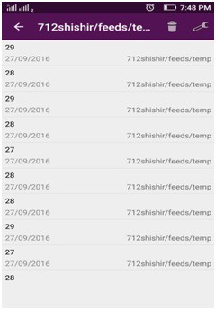

Fig. 8. Results from MQTT app on Smartphone for temperature

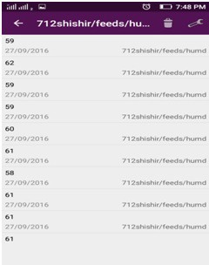

Fig. 9. Results from MQTT app on Smartphone for humidity

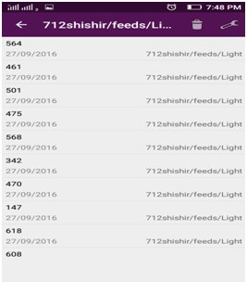

Fig. 10. Results from MQTT app on Smartphone for light intensity level

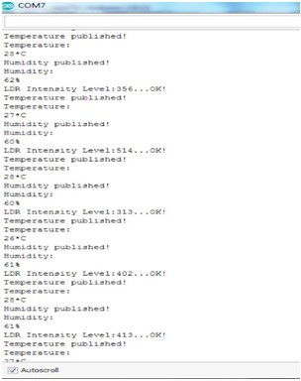

Fig. 11. Results obtained on Serial Monitor of Arduino IDE

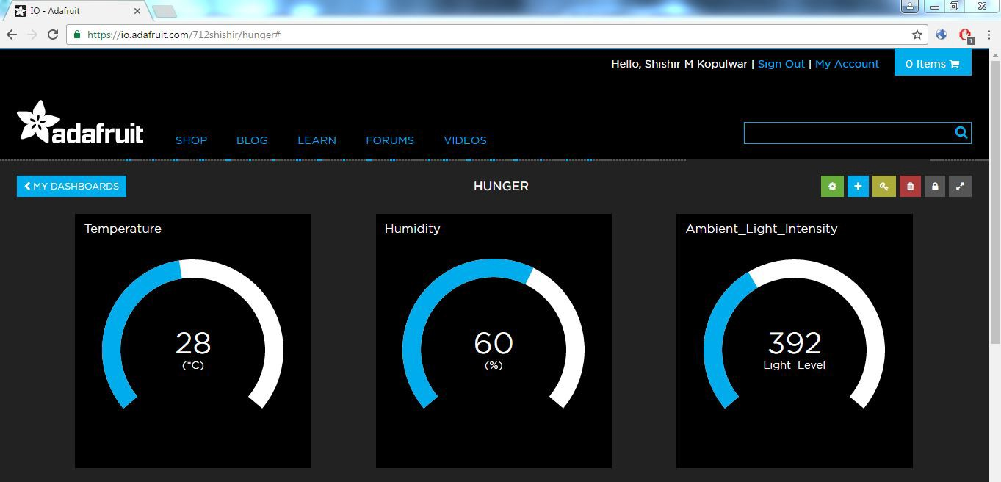

Fig. 12. Results shown on Adafruit IO dashboard

1. CONCLUSION

Thus MQTT protocol is very easy to implement which provides some degree of guaranty about delivery of messages. The Adafruit IO facilitates good user interface and creates simple device communication using MQTT protocol. As per the requirements the more number of the peripheries can be easily integrated to the system with a little change in its core by means of which a low cost, low power consumption system can be designed and implemented.

REFERENCES

1. Satyavrat Wagle,Semantic Data Extraction over MQTT for IoTcentric Wireless Sensor Networks, 2016 International Conference on Internet of Things and Applications (IOTA) Maharashtra Institute of Technology,

Pune, India 22 Jan - 24 Jan, 2016

1. Aimaschana Niruntasukrat, Chavee Issariyapat, Panita Pongpaibool, Koonlachat Meesublak, Pramrudee Aiumsupucgul, Anun Panya, Authorization Mechanism for MQTT-based Internet of Things, IEEE ICC2016-Workshops: W07-Workshop on Convergent Internet of Things
2. Meena Singh, Rajan MA, Shivraj VL, and Balamuralidhar P, Secure MQTT for Internet of Things (IoT), 2015 Fifth International Conference on Communication Systems and Network Technologies
3. Yuvraj Upadhyay, Mr.Amol Borole, Mr.D.Dileepan, MQTT Based Secured Home Automation System, 2016 Symposium on Colossal Data Analysis and Networking (CDAN)
4. Ullas B S, Anush S, Roopa J, Govinda Raju M, Machine to Machine Communication for Smart Systems using MQTT, International Journal of Advanced Research in Electrical, Electronics and Instrumentation Engineering
5. Valerine Lampkin, Weng Tat Leong, Leonardo Olivera, Sweta Rawat, Nagesh Subrahmanyam, Rong Xiang, Building Smarter Planet Solutions with MQTT and IBM WebSphere MQ Telemetry, First Edition, September 2012.
6. https://learn.adafruit.com/adafruit-io/overview
7. <http://mqtt.org/>
8. <http://smartcities.gov.in/>
9. https://espressif.com/en/products/hardware/esp8266ex/overview
10. <http://www.micropik.com/>
11. [https://www.adafruit.com/](http://www.adafruit.com/)
12. <http://www.hivemq.com/blog/mqtt-toolbox-mqtt-spy>
13. [http://www.4-direct.com/resistor/photo-cds.htm.](http://www.4-direct.com/resistor/photo-cds.htm)
14. L. mainetti, L.Manco, L.Patrono, I.Sergi, R. Vergallo, Web of Topics:An IoT aware Model-driven Designing approach, 2015 IEEE 2nd World Forum on, 14-16 Dec 2015.
15. Ghassan Maan Salim, Hashimah Ismail, Niranjan Debnath, A.Nadya, Optical Light Power Consumption using LDR Sensor, IEEE IRIS2015.
16. Satyavrat Wagle,Semantic Data extraction over MQTT for IOTcentric Wirelesss Sensor Networks, 2016 International Conference on IOTA, 22-24 Jan 2016.